DATABASE SYSTEM ENGINEERING AND DISTRIBUTED BACKEND DEVELOPMENT

Name: CH.Srihitha
Roll No:2520030400
Section: 7

Step 1: Create the Database and First Collection
Database Name : bankdb
Collection Name : customers

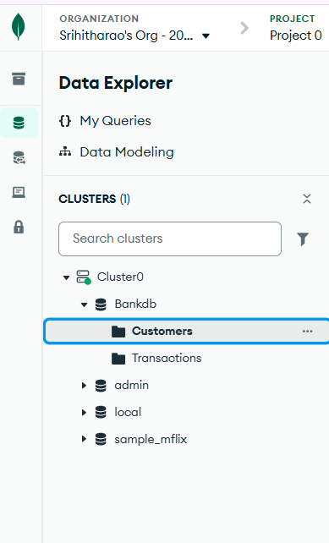

Step 2: Insert Customer Data (8 Documents)
Open bankdb → customers → Documents. Click Add Data → Insert Document. Insert each of the following JSON documents one at a time, then click Insert.
{ "customer_id": 101, "name": "Ravi Kumar", "city": "Hyderabad",
"account_type": "Savings", "balance": 85000, "status": "Active" }

{ "customer_id": 102, "name": "Priya Sharma", "city": "Vijayawada",
"account_type": "Current", "balance": 125000, "status": "Active" }

{ "customer_id": 103, "name": "Arjun Reddy", "city": "Hyderabad",
"account_type": "Savings", "balance": 45000, "status": "Active" }

{ "customer_id": 104, "name": "Sneha Rao", "city": "Warangal",
"account_type": "Savings", "balance": 210000, "status": "Active" }

{ "customer_id": 105, "name": "Kiran Kumar", "city": "Guntur",
"account_type": "Current", "balance": 65000, "status": "Inactive" }

{ "customer_id": 106, "name": "Anjali Singh", "city": "Hyderabad",
"account_type": "Savings", "balance": 175000, "status": "Active" }

{ "customer_id": 107, "name": "Rahul Verma", "city": "Bengaluru",
"account_type": "Current", "balance": 95000, "status": "Active" }

{ "customer_id": 108, "name": "Meena Devi", "city": "Chennai",
"account_type": "Savings", "balance": 320000, "status": "Active" }

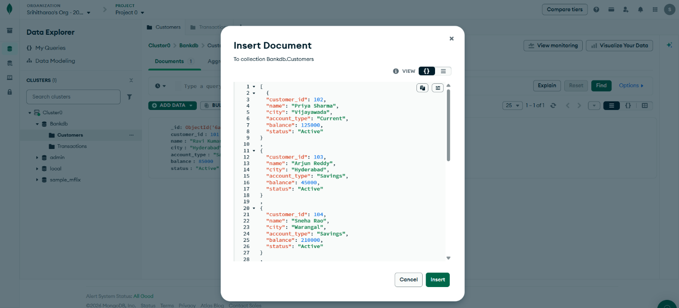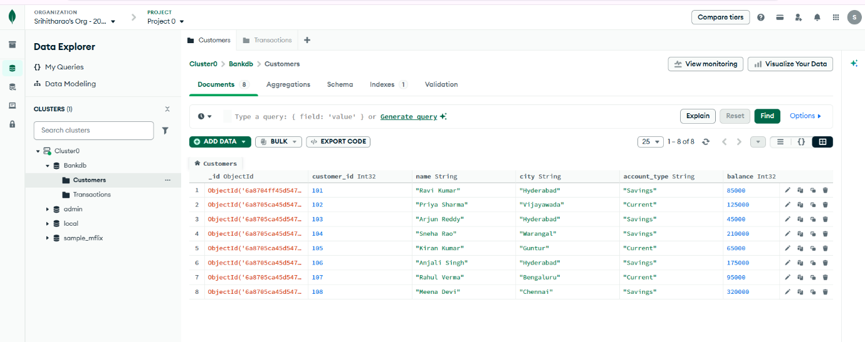

Step 3 : Insert Transaction Data (15 Documents)
Open bankdb → transactions → Documents. Click Add Data → Insert Document. Insert each transaction JSON one at a time.
{ "transaction_id": 1001, "customer_id": 101, "type": "Deposit",
"amount": 25000, "mode": "UPI", "date": "2026-08-01", "status": "Success" }

{ "transaction_id": 1002, "customer_id": 101, "type": "Withdrawal",
"amount": 10000, "mode": "ATM", "date": "2026-08-02", "status": "Success" }

{ "transaction_id": 1003, "customer_id": 102, "type": "Deposit",
"amount": 50000, "mode": "NEFT", "date": "2026-08-02", "status": "Success" }

{ "transaction_id": 1004, "customer_id": 102, "type": "Withdrawal",
"amount": 15000, "mode": "ATM", "date": "2026-08-03", "status": "Success" }

{ "transaction_id": 1005, "customer_id": 103, "type": "Deposit",
"amount": 30000, "mode": "UPI", "date": "2026-08-03", "status": "Success" }

{ "transaction_id": 1006, "customer_id": 103, "type": "Withdrawal",
"amount": 5000, "mode": "ATM", "date": "2026-08-04", "status": "Success" }

{ "transaction_id": 1007, "customer_id": 104, "type": "Deposit",
"amount": 100000, "mode": "NEFT", "date": "2026-08-04", "status": "Success" }

{ "transaction_id": 1008, "customer_id": 104, "type": "Withdrawal",
"amount": 25000, "mode": "ATM", "date": "2026-08-05", "status": "Success" }

{ "transaction_id": 1009, "customer_id": 105, "type": "Deposit",
"amount": 15000, "mode": "UPI", "date": "2026-08-05", "status": "Success" }

{ "transaction_id": 1010, "customer_id": 106, "type": "Deposit",
"amount": 75000, "mode": "NEFT", "date": "2026-08-06", "status": "Success" }

{ "transaction_id": 1011, "customer_id": 106, "type": "Withdrawal",
"amount": 20000, "mode": "ATM", "date": "2026-08-06", "status": "Success" }

{ "transaction_id": 1012, "customer_id": 107, "type": "Deposit",
"amount": 40000, "mode": "IMPS", "date": "2026-08-07", "status": "Success" }

{ "transaction_id": 1013, "customer_id": 107, "type": "Withdrawal",
"amount": 12000, "mode": "ATM", "date": "2026-08-07", "status": "Success" }

{ "transaction_id": 1014, "customer_id": 108, "type": "Deposit",
"amount": 150000, "mode": "NEFT", "date": "2026-08-08", "status": "Success" }

{ "transaction_id": 1015, "customer_id": 108, "type": "Withdrawal",
"amount": 30000, "mode": "ATM", "date": "2026-08-08", "status": "Success" }

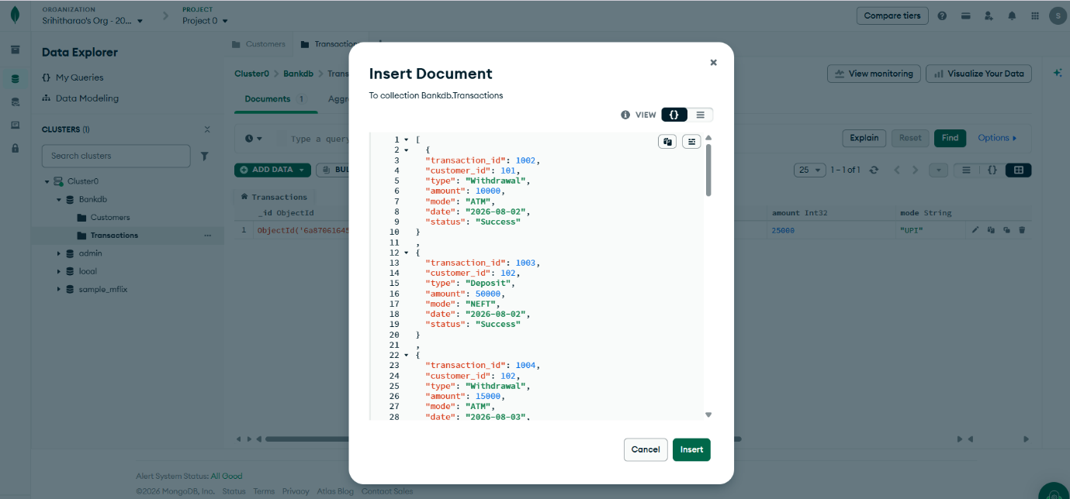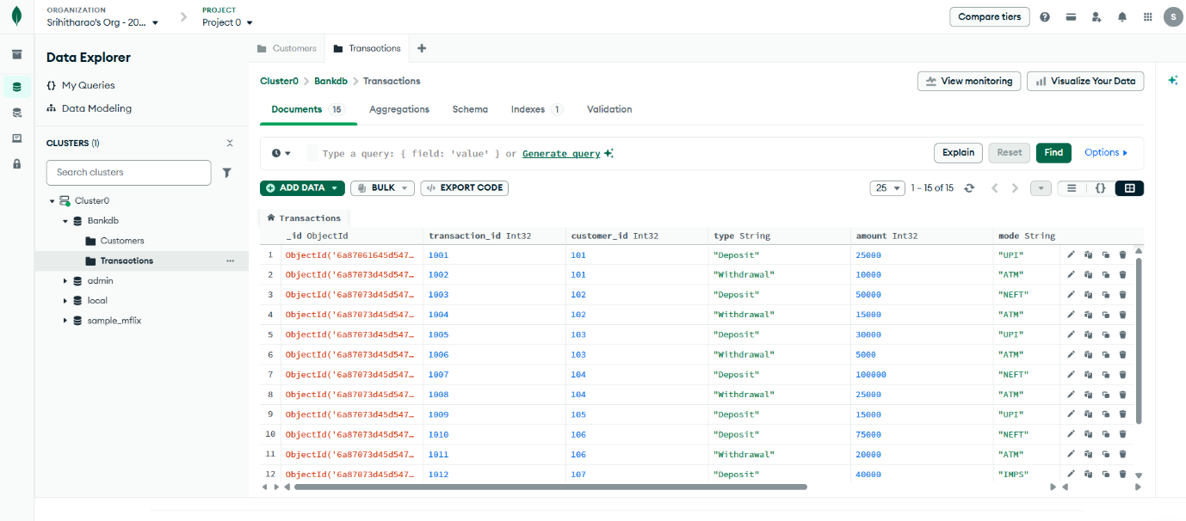

Basic Find Queries (Q1 – Q11)
For each query below: open the collection → Documents tab → paste the filter JSON into the Filter box → click Find.

Query 1: Display All Customers
Collection: customers
{}

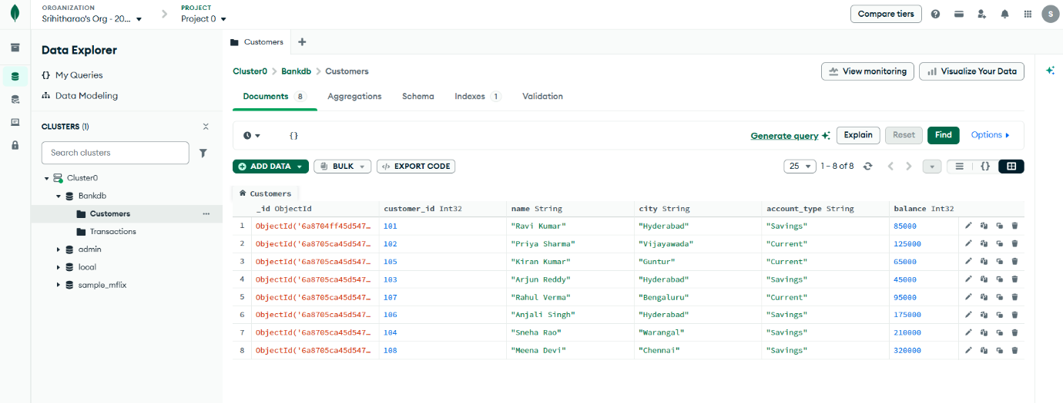

Query 2: Find Active Customers
Filter:

{
"status": "Active"
}

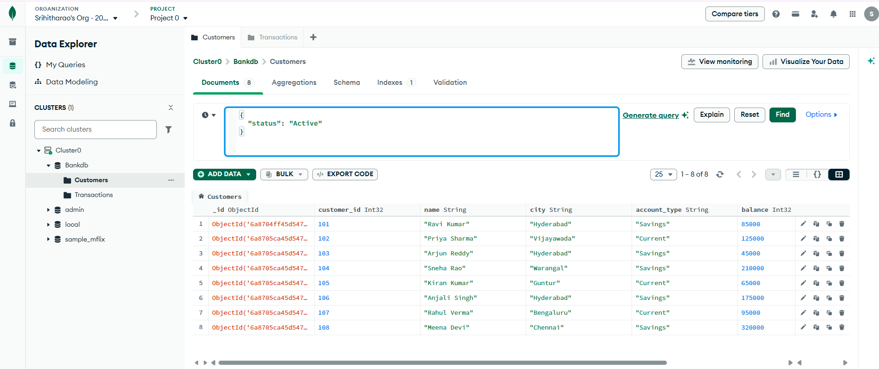

Query 3: Find Customers With Balance Greater Than 100000
Filter:

{
"balance": {
"$gt": 100000
}

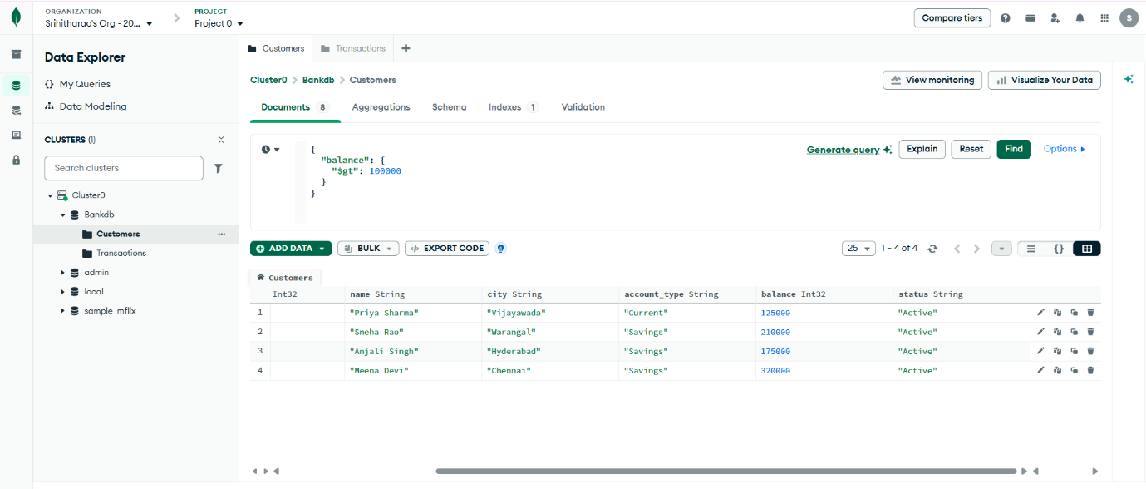 Query 4: Find Hyderabad Customers
Filter:

{
"city": "Hyderabad"
}

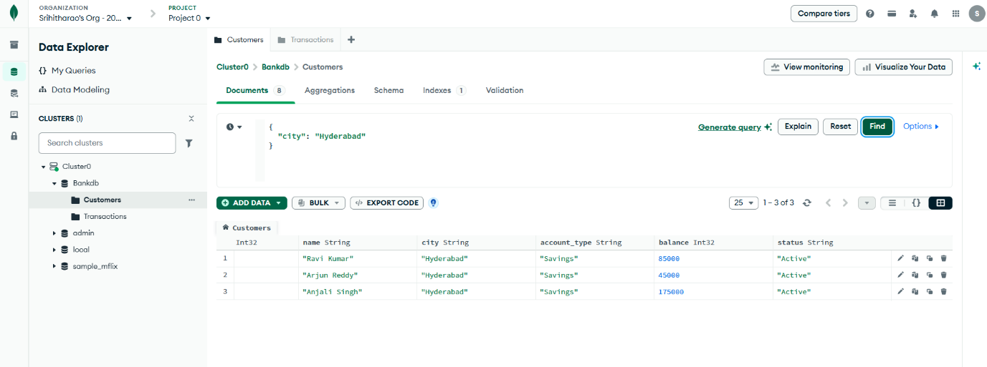

Query 5: Find Savings Account Customers
Filter:

{
"account_type": "Savings"
}

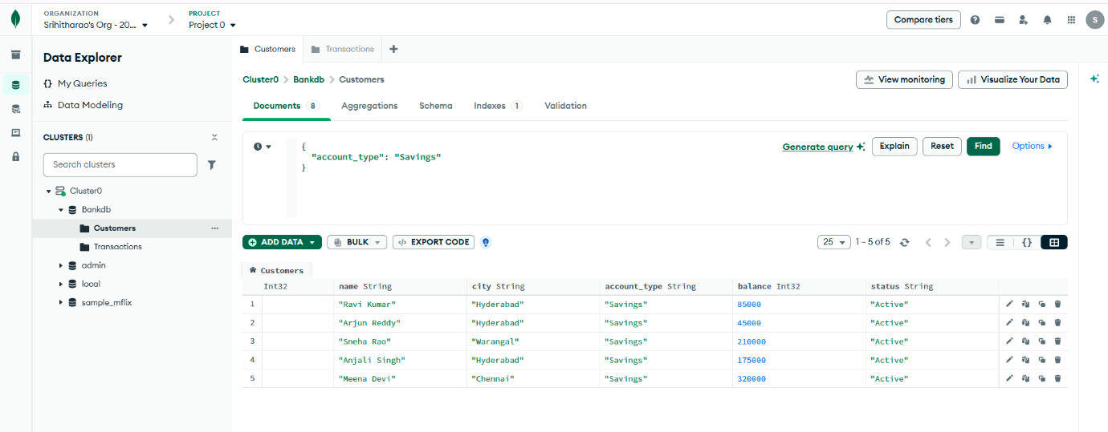 Query 6: Find Transactions Greater Than 20000
Open:

transactions
|
+---- Documents

Filter:

{
"amount": {
"$gt": 20000
}
}

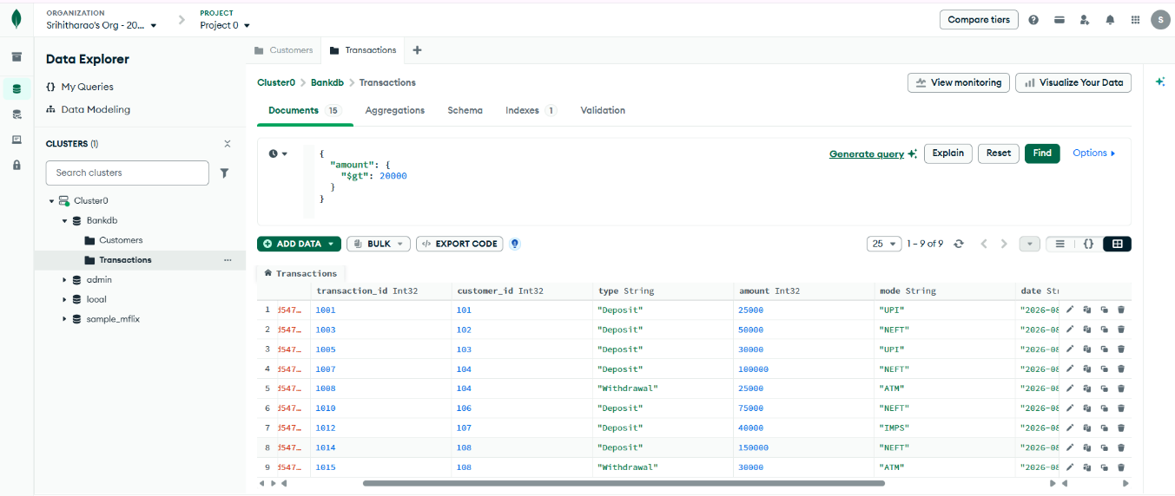

Query 7: Find Deposits
Filter:

{
"type": "Deposit"
}

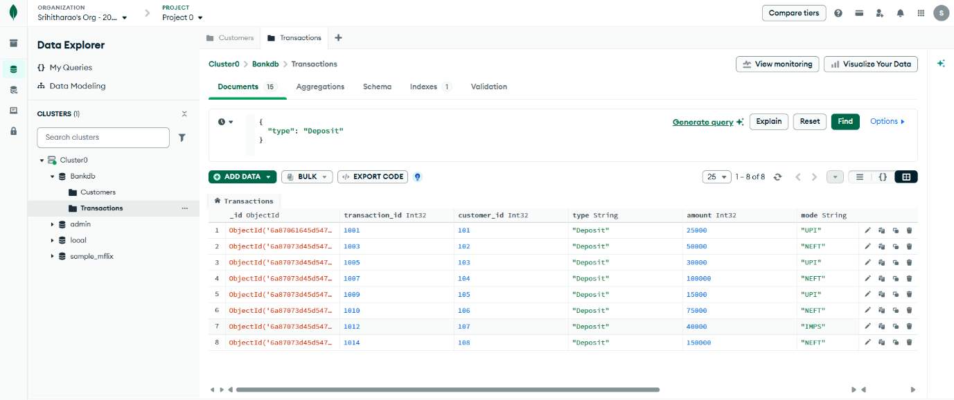 Query 8: Find Atm Transactions
Filter:

{
"mode": "ATM"
}

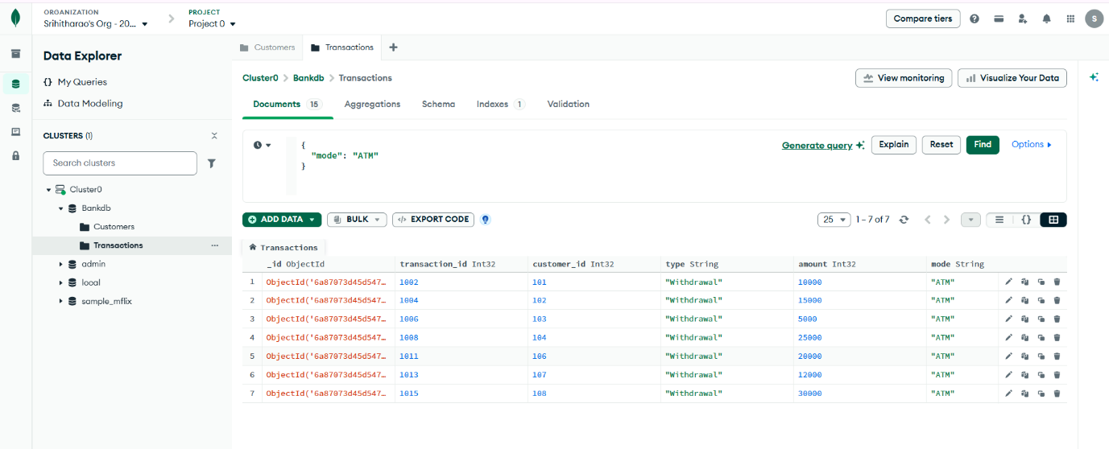 Query 9: Find Deposits Greater Than 50000
Filter:

{
"type": "Deposit",
"amount": {
"$gt": 50000
}

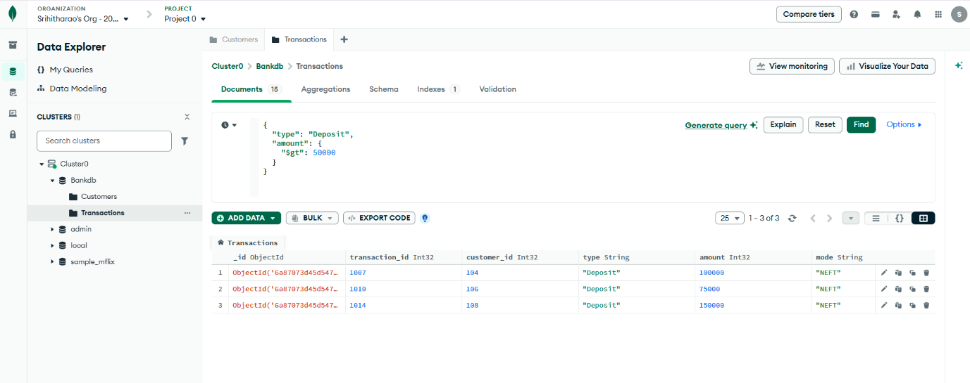 Query 10: Find Hyderabad Customers With High Balance
Filter:

{
"city": "Hyderabad",
"balance": {
"$gt": 100000
}
}

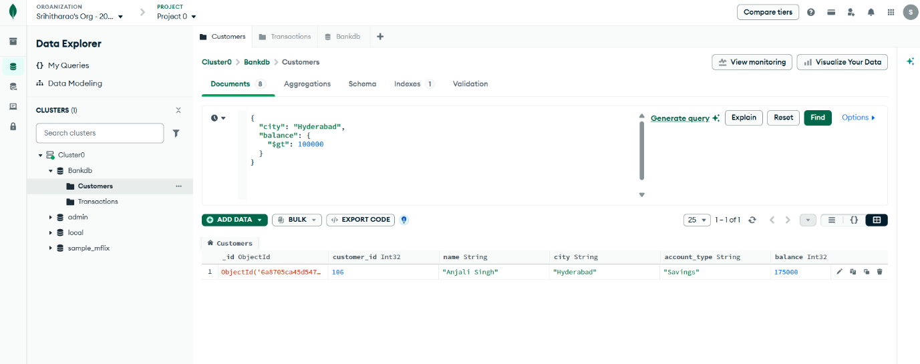 Query 11: Find Customers In Multiple Cities
Filter:

{
"city": {
"$in": [
"Hyderabad",
"Vijayawada",
"Warangal"
]
}
}

